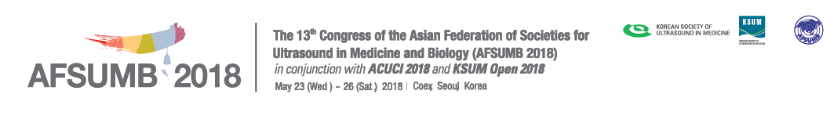
Hotel Reservation Form: Inter Continental Seoul Coex

Please complete this form and return it directly by fax or email to us no later than May 1, 2018.
Reservation Dept. for Reservation - Phone: +82-2-559-7777, Fax: +82-2-559-7896, Email: ic-convention@parnas.co.kr

A. Participant Information *Please type or print clearly
Title Mr. Ms. Dr. Prof.
First Name |  |  |  | Last Name
[Only Korean] 국문 성명 |  |  |  | 국문 소속
Affiliation |  |  |  | Country
E-mail |  | Tel |  |  |  | Fax
Check-in | Date: | Check-out | Date: |  | No. of Nights
 | Time: |  | Time: |  | No. of Rooms

B. Accompanying Person
First Name | Last Name | Mr. / Ms.

C. Room Rates
Class | Hotel | Room Type |  | Distance to Venue
 |  | Superior Room (Single) | Superior Room (Double/Twin)
★★★★★ | Intercontinental Seoul Coex | KRW 240,000 | KRW 270,000 | Hotel Venue
*Note
1. The room rates are fixed in Korean Won.
2. Hotel will directly send you the confirmation for your room reservation.
3. Additional KRW 30,000 (subject to total 21 % service charge & tax) for double occupancy charge.
∗ Breakfast rate per person is KRW 30,000 (Subject to total 21% service charge & tax).
∗ Superior Room rates are breakfast exclusive.
∗ All of the above room & breakfast rates are subject to total 21% service charge & tax.
∗ The above rate is including Internet access in room daily.
4. Check-in time is 15:00 p.m. and check-out time is 12:00 noon.
D. Payment Information
In order to guarantee your room reservation, your credit card information must be provided.
Card Type: □ Visa □ Master □ Diners □ JCB □ Others ( )
Card No.:
Expiration Date: / (mm/yy)
Cardholder’s Name: Cardholder’s Signature:
E. Cancellation Policy
1. Any change or cancellation should be informed by e-mail or fax to contact person directly as below.
2. Cancellation made after 7 days prior to arrival including no-shows: Whole nights room charge including service charge & tax

F. Please complete this form and return it directly to hotel by fax or e-mail.
Hotel | Contact person | Tel. | Fax | E-mail
Intercontinental Seoul Coex | Reservation Department | +82-2-559-7777 | +82-2-559-7896 | ic-convention@parnas.co.kr

